BYU-Pathway Worldwide Devotional

“You Belong in the Light of Christ”
Patrick Kearon
Quorum of the Twelve Apostles
August 01, 2025
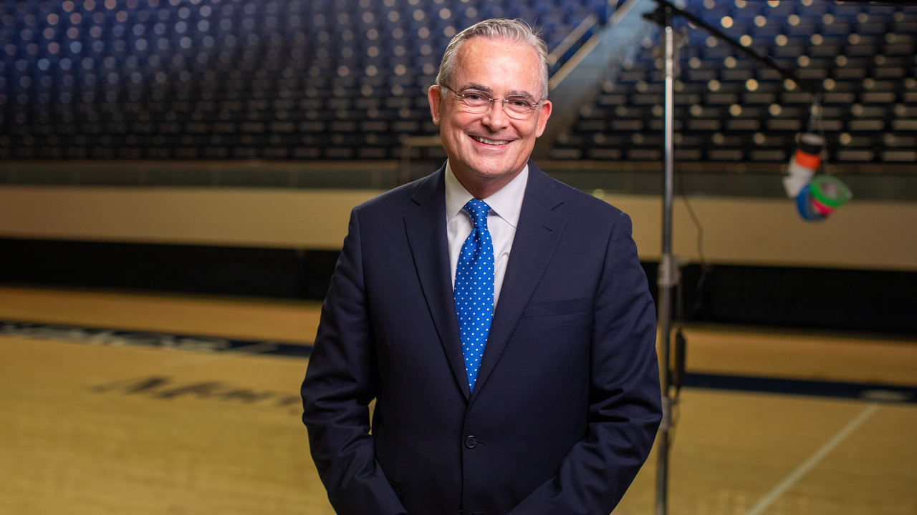
Play Video
PlayPause-10 secs00:0009:25+10 secs
1x
VolumeMutedDownload
Dismiss
Your download has started and may take several minutes to complete.
Listen

You can view or print this speech in the following languages:
English | French | Portuguese | Spanish
First and foremost, thank you for your faithful approach to your studies. Thank you for participating in BYU-Pathway. I trust that it’s a great blessing in your life already, and I pray that it will continue to be a wonderful blessing for you and for those you love, in time.
From darkness to light
Today I am standing in an empty arena. It is vast. It’s silent. It’s as if it’s waiting. The purpose of this place is sports games, concerts, public events, and, without those here, it feels meaningless. What it’s symbolizing in terms of what I want to share with you is a world without the gospel, a world without Jesus Christ, a world without His light. It is empty. It is joyless. It is lacking any kind of connection. Now I want you to picture the arena full, alive, purposeful — filled with community and excitement and energy.
I have been here when it is brimming with that energy. In fact, it is very strange to be here when it’s not. It feels cold and empty. But as you imagine the arena full, imagine the light of the gospel — the world without that light — for so long until Joseph went into that wood and described thick darkness at first. Until he was filled with divine light as the Father and the Son, as God our Father in Heaven and as Jesus Christ appeared to him — the ultimate in terms of going from darkness to light.
In Doctrine and Covenants 45:7, we read, “For verily I say unto you that I am Alpha and Omega, the beginning and the end, the light and the life of the world — a light that shineth in darkness and the darkness comprehendeth it not.”i
I’ve always wondered about that: darkness not comprehending the light. And I think of my own journey that was by measures from darkness to light. And it was very hard to understand in some ways that light at the beginning.
You belong in the light of Christ
The Church is full of imperfect people. In fact, we are all imperfect. The gospel is perfect. The love of God, exquisite and perfect. The atoning gift of His Son, Jesus Christ, equally perfect. Now, as you think about this arena full, we realize that even then, even with all of that energy, with all of that light, there will still be struggles. There will be those who are here, aware of their own imperfections. There will be those here who are not aware of their own imperfections. And there will be frustrated fans and players, symbolizing conflict and discouragement and imperfection — whether that’s our internal thoughts or the external experience of being here with a game going on.
Spiritual noise is all around, interfering with our image of our true selves, our understanding of who we really are. Some of the interference, some of the noise that you may have and need to cancel out is the understanding that you belong, you belong in your community, you belong in your study group, you belong in your place of work, you belong in your family. And for those of you who do believe, you certainly belong in the Church and in the gospel. And for those who haven’t yet found their faith, you belong in the family of our loving Father in Heaven and we are all brothers and sisters.
The light of Christ is in all of us. Everyone is born with divine light. We sense this with newborn babies and young children. For those of you who may have lost some of this light, I pray that you’ll find it again. I pray that you will come to a better understanding of repentance: turning around, trying again, finding a new beginning.
In Luke we can read, “Through the tender mercy of our God; whereby the dayspring from on high hath visited us, To give light to them that sit in darkness and in the shadow of death, to guide our feet into the way of peace.”ii
Joy in Christ changed everything
You and I are here to help guide our friends from darkness, or relative darkness, toward the light. My own journey began with a sense of joy as I met members of the Church. Joy in Christ changed everything for me as I discovered along the way that he does bring light and life into our lives. He brings happiness, peace, and joy.
I hope that we can love all of those around us. Sometimes that’s challenging when we think again of the sporting events that go on here. We can think of loving those on other teams, showing mercy and love as the Savior Jesus Christ did — even when we may feel rejected.
Wear the colors of your team comfortably and happily. Show who you cheer for. Believe in a way that will have others around you want to join you in your faithful life.
This empty arena is unsettling. It is like life without gospel light. It is directionless and literally cold; yet, we live in gospel light, and, if we aren’t there now, we can.
Light overcomes darkness
President Nelson has said, “The increasing darkness that accompanies tribulation makes the light of Jesus Christ shine ever brighter.”iii
Yes, there are distractions. They will remain. But so will joy and so will light, and the gospel brings connection, hope, and excitement — and that will displace the darkness.
I pray that you will find this light, this joy, this peace, perhaps for the first time. If the light has slipped away from you a little (or more than that), I pray that you’ll rediscover it. I pray that you’ll live in a way that will help you feel it and be blessed by it. I pray that if you have it brightly with you now that you find wonderful, comfortable ways to share it.
Light does overcome darkness. It can for you. I pray that it is or, if it hasn’t yet, that it will. I pray that you will succeed in every righteous endeavor. I pray that you will come to love your studies, and that they will bless you in many wonderful ways — ways that you are hoping for and ways that will surprise you.
I testify of a loving Father in Heaven. Our Father in Heaven loves you more than you can imagine. He sent His Son, Jesus Christ, to bless you and to take away every sin and so much of your pain and anxiety and suffering. I pray that you will come to an understanding of that, and that you will be blessed, and then that you will share these blessings with those around you. In the name of Jesus Christ, amen.

“Perteneces a la luz de Cristo”
Patrick Kearon
Cuórum de los Doce Apóstoles
1 de agosto de 2025
VolumenSilenciadoDescargar
Descartar
Tu descarga ha comenzado y puede tardar varios minutos en completarse.
Escuchar

Puedes ver o imprimir este discurso en los siguientes idiomas:
Inglés | Francés | Portugués | Español
En primer lugar, gracias por su fiel dedicación a sus estudios. Gracias por participar en BYU-Pathway. Confío en que ya es una gran bendición en su vida y oro para que siga siendo una maravillosa bendición para usted y para sus seres queridos con el tiempo.
De la oscuridad a la luz
. Hoy estoy de pie en un estadio vacío. Es vasto. Está en silencio. Es como si estuviera esperando. El propósito de este lugar son los juegos deportivos, los conciertos, los eventos públicos y, sin ellos, se siente sin sentido. Lo que simboliza en términos de lo que quiero compartir con ustedes es un mundo sin el evangelio, un mundo sin Jesucristo, un mundo sin su luz. Está vacío. Está sin alegría. Carece de cualquier tipo de conexión. Ahora quiero que imaginen el estadio lleno, vivo, con propósito, lleno de comunidad, emoción y energía
He estado aquí cuando rebosa de esa energía. De hecho, es muy extraño estar aquí cuando no la hay. Se siente frío y vacío. Pero al imaginar el estadio lleno, imagina la luz del evangelio, el mundo sin esa luz, durante tanto tiempo hasta que José entró en ese bosque y describió una densa oscuridad al principio. Hasta que fue lleno de luz divina como el Padre y el Hijo, como Dios nuestro Padre en los Cielos y como Jesucristo se le apareció, lo máximo en términos de pasar de la oscuridad a la luz
En Doctrina y Convenios 45:7, leemos: “Porque de cierto os digo que yo soy el Alfa y la Omega, el principio y el fin, la luz y la vida del mundo; una luz que resplandece en las tinieblas, y las tinieblas no la comprenden”.i
Siempre me he preguntado sobre eso: que la oscuridad no comprenda la luz. Y pienso en mi propio viaje, que fue por etapas, de la oscuridad a la luz. Y fue muy difícil comprender, en cierto modo, esa luz al principio
Tu lugar está en la luz de Cristo.
La Iglesia está llena de personas imperfectas. De hecho, todos somos imperfectos. El evangelio es perfecto. El amor de Dios, exquisito y perfecto. El don redentor de su Hijo, Jesucristo, igualmente perfecto. Ahora bien, al pensar en este estadio lleno, comprendemos que incluso con toda esa energía y toda esa luz, seguirá habiendo dificultades. Habrá quienes estén aquí, conscientes de sus propias imperfecciones. Habrá quienes no lo sean. Y habrá aficionados y jugadores frustrados, que simbolizan el conflicto, el desaliento y la imperfección, ya sea en nuestros pensamientos internos o en la experiencia externa de estar aquí, presenciando un partido.
El ruido espiritual está por todas partes, interfiriendo con nuestra imagen de nosotros mismos, con nuestra comprensión de quiénes somos realmente. Parte de la interferencia, parte del ruido que puede tener y que necesita cancelar es la comprensión de que usted pertenece, pertenece a su comunidad, pertenece a su grupo de estudio, pertenece a su lugar de trabajo, pertenece a su familia. Y para aquellos de ustedes que sí creen, ciertamente pertenecen a la Iglesia y al evangelio. Y para aquellos que aún no han encontrado su fe, pertenecen a la familia de nuestro amoroso Padre Celestial y todos somos hermanos y hermanas.
La luz de Cristo está en todos nosotros. Todos nacen con luz divina. Sentimos esto en los bebés recién nacidos y en los niños pequeños. Para aquellos de ustedes que puedan haber perdido algo de esta luz, oro para que la encuentren de nuevo. Oro para que lleguen a una mejor comprensión del arrepentimiento: dar la vuelta, intentarlo de nuevo, encontrar un nuevo comienzo
En Lucas podemos leer: “Por la entrañable misericordia de nuestro Dios, por la cual nos visitó la aurora desde lo alto, para dar luz a los que habitan en tinieblas y en sombra de muerte, para guiar nuestros pasos por el camino de la paz.”ii
El gozo en Cristo lo cambió todo.
Tú y yo estamos aquí para ayudar a guiar a nuestros amigos desde la oscuridad, o la relativa oscuridad, hacia la luz. Mi propio viaje comenzó con una sensación de gozo al conocer a miembros de la Iglesia. El gozo en Cristo lo cambió todo para mí al descubrir en el camino que él sí trae luz y vida a nuestras vidas. Él trae felicidad, paz y gozo.
Espero que podamos amar a todos los que nos rodean. A veces eso es un desafío cuando pensamos de nuevo en los eventos deportivos que se llevan a cabo aquí. Podemos pensar en amar a los de otros equipos, mostrando misericordia y amor como lo hizo el Salvador Jesucristo, incluso cuando nos sintamos rechazados.
Viste los colores de tu equipo con comodidad y alegría. Muestra a quién animas. Cree de una manera que haga que otros a tu alrededor quieran unirse a ti en tu vida de fe
Este estadio vacío resulta inquietante. Es como la vida sin la luz del evangelio. Carece de rumbo y es literalmente fría; sin embargo, vivimos en la luz del evangelio y, si ahora no estamos ahí, podemos estarlo.
La luz vence a la oscuridad.
El presidente Nelson dijo: “La creciente oscuridad que acompaña a la tribulación hace que la luz de Jesucristo brille cada vez más”.iii
Sí, hay distracciones. Permanecerán. Pero también lo harán el gozo y la luz, y el Evangelio trae conexión, esperanza y entusiasmo, y eso desplazará la oscuridad.
Oro para que encuentres esta luz, este gozo, esta paz, tal vez por primera vez. Si la luz se te ha alejado un poco (o más que eso), oro para que la redescubras. Oro para que vivas de una manera que te ayude a sentirla y a ser bendecido por ella. Oro para que, si la tienes brillantemente contigo ahora, encuentres maneras maravillosas y cómodas de compartirla
La luz sí vence a la oscuridad. Puede hacerlo por ti. Oro para que así sea o, si aún no lo ha sido, para que lo sea. Oro para que tengas éxito en todo esfuerzo justo. Oro para que llegues a amar tus estudios y que te bendigan de muchas maneras maravillosas: maneras que esperas y maneras que te sorprenderán.
Testifico de un Padre Celestial amoroso. Nuestro Padre Celestial te ama más de lo que puedes imaginar. Envió a su Hijo, Jesucristo, para bendecirte y quitarte todo pecado y gran parte de tu dolor, ansiedad y sufrimiento. Oro para que llegues a comprender eso, que seas bendecido y que compartas estas bendiciones con quienes te rodean. En el nombre de Jesucristo, amén.

🧠 Devotional Summary: "You Belong in the Light of Christ"
Elder Patrick Kearon of the Quorum of the Twelve Apostles uses the contrast between an empty stadium and a stadium full of life to illustrate the difference between a world without the Gospel and a world illuminated by Jesus Christ.

From Darkness to Light
The empty stadium represents a world without the Gospel and without the Light of Christ: it is vast, silent, empty, joyless, and lacking connection.
The stadium, full of life and vitality, represents the world with the Light of the Gospel, which brings purpose, community, excitement, and energy.
He cites the experience of Joseph Smith, who went from a "thick darkness" to being "filled with divine light" after being visited by the Father and the Son.
He quotes D&C 45:7: "For verily I say unto you that I am the Alpha and the Omega, the beginning and the end, the light and the life of the world—a light that shineth in darkness and the darkness comprehendeth it not."

You Belong in the Light of Christ
The Church is full of imperfect people, but the Gospel, the love of God, and the attainable gift of Jesus Christ are perfect.
Despite difficulties and imperfections, the main message is that everyone belongs: to our community, study groups, workplace, family, and to the Church. We are all brothers and sisters in the family of a loving Heavenly Father.
We are all born with the divine light of Christ. For those who may have lost it, Elder Kearon prays that they will find repentance (change of mind, trying again) and thus find a new beginning.
He quotes Luke regarding God’s tender mercy to "give light to them that sit in darkness and in the shadow of death, to guide our feet into the way of peace."

Light Overcomes Darkness
The joy that Christ brings to life changes everything, providing light, life, happiness, and peace.
We are invited to show love and mercy to everyone around us.
Despite distractions and tribulations, the Gospel brings connection, hope, and enthusiasm, which displace the darkness.
Elder Kearon testifies that Heavenly Father loves us more than we can imagine and sent His Son, Jesus Christ, to bless us and take away all sin and much of our pain, anxiety, and suffering.

❓ Discussion Questions
Here are the suggested reflections for each question:

1. How has the light of Jesus Christ blessed your life or the life of your family?
Suggested Answer:
The Light of Christ has blessed me by giving me hope and perspective during difficult times (e.g., health or financial issues), helping me see beyond the immediate challenge.
In my family, it is manifested through patience and unity. When we focus on the Gospel, communication improves, conflicts decrease, and we feel a greater unconditional love for one another, turning the home into a place of peace (the "battleground").

2. How do you usually share the joy of Jesus Christ with others?
Suggested Answer:
Through example: living my covenants with joy and optimism so that my life reflects something others want to be a part of. As Elder Kearon says: "Believe in such a way that those around you desire to join you."
By showing love and kindness to others, even when they don't belong to my group (neither my social circle nor my belief system). This includes practical help and sincere service.
By openly sharing the blessings I receive through faith and testifying of the peace that repentance and the Atonement bring.

3. How do you find and hold on to the light of Jesus Christ to overcome the darkness that accompanies life's challenges? How does that light help provide hope?
Suggested Answer:
Finding the light: I find it mainly through daily scripture study, sincere prayer, and service. These are the "sources of light" that help me come out of the darkness.
Holding on to the light: I hold on to it by remembering that I am imperfect and the Gospel is perfect. Constant repentance (turning around and trying again) allows me to draw on the Atonement.
Light as hope: The light gives me hope because it assures me that I am not alone. It reminds me of the infinite love of Heavenly Father and the sacrifice of Christ, which means my mistakes and suffering are temporary and can be redeemed. This hope allows me to keep moving forward even when the path is dark.

